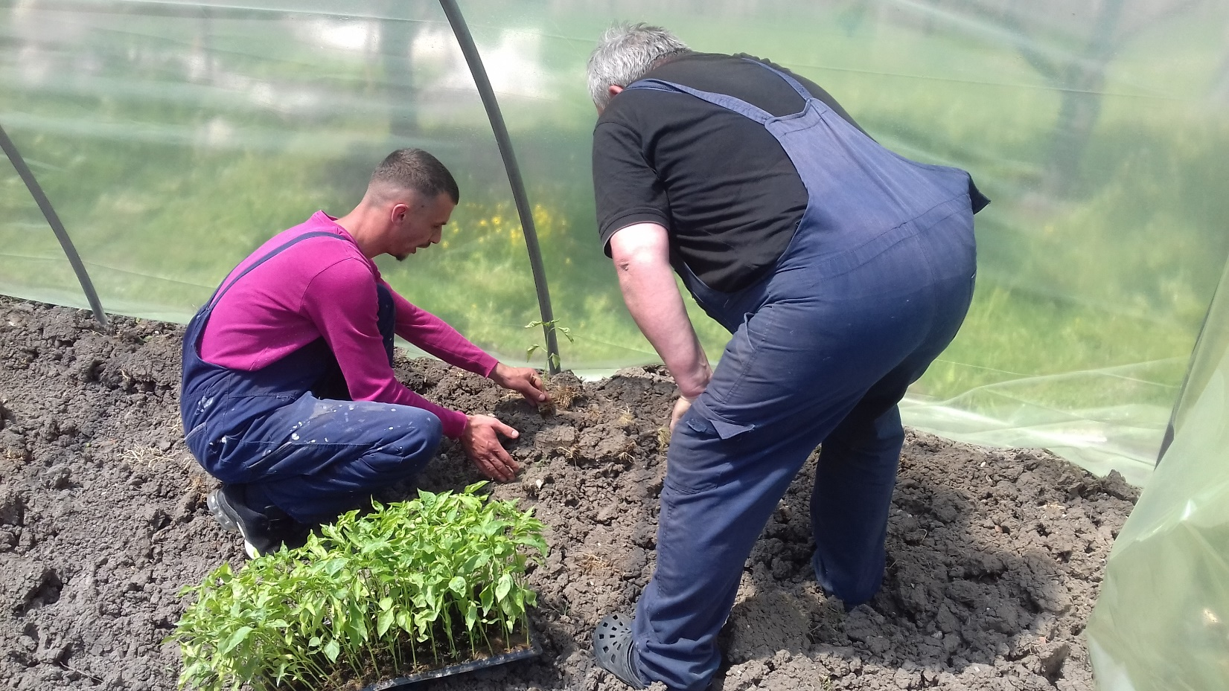Project ” Socio economic reintegration of vulnerable families”

The project is supported by Caritas Austria (Caritas Tirol) and their actions seek to respond to the most poverty affected category, (women, youth, returnees and families living in social deprived situation living in rural area).
The overall goal of the propose project is Contributing to promotion of family small scales entrepreneurships in the rural area as a mean of family empowerment and economic growth. Most rural households depend largely on crop and livestock production for their income. Poor people in rural areas are either members of traditional small-scale agricultural households making out a livelihood at subsistence level, or they are among the poor rural unemployed, who may be even more disadvantaged than poor landholders. This projects aims to alleviate rural poverty by supporting the development of small businesses for poor families, women and minority group members. This way they will acquire skills and means that will enable them to financially support themselves, their families and their surroundings, and result in sustainable economic, social and environmental development. By end of the project twenty four beneficiaries will have received small scale grants for cultivation of veggies and beekeeping.
- 24 families have received self-employing grants and are able to generate sustainable income.
- 24 families/women/returnees have attained practical skills on beekeeping / green-housing cultivation and have extended skills on savings

The project was based on theory of change with combination of six clusters of activities which were proven successful by researchers of the MIT Princeton, on creating lasting progress for the poor.
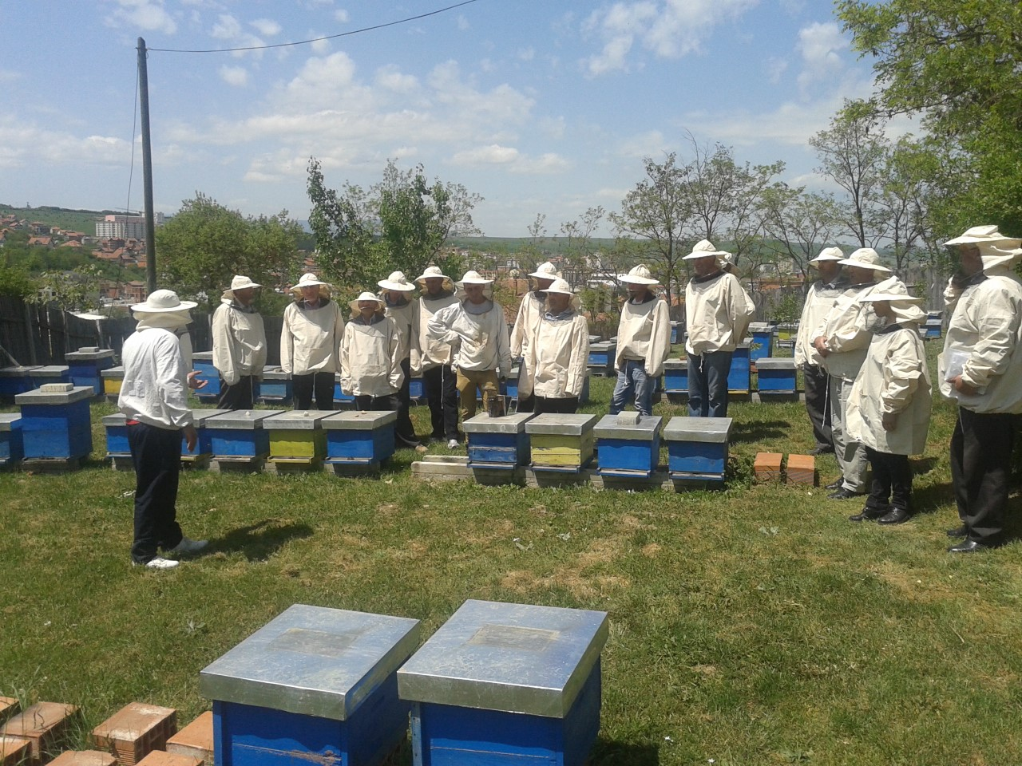
This is a 12 month project and it is implemented during the year January- December 2019 with total approved contract of funding 39.929.83 euros.

Mother Teresa Society is grateful for the cooperation with Caritas Network for more than two decades, together we have helped so many people in need, provided means, shelter and above all the hope for better future.

