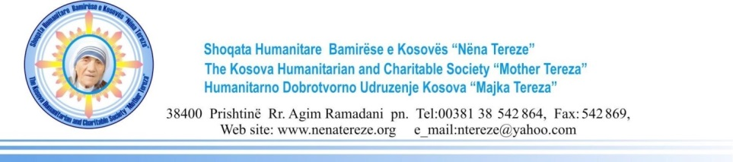
From Loppan Hoganas to Kosovo,
“Supporting Kosovo vulnerable community through Safety Net Projects”
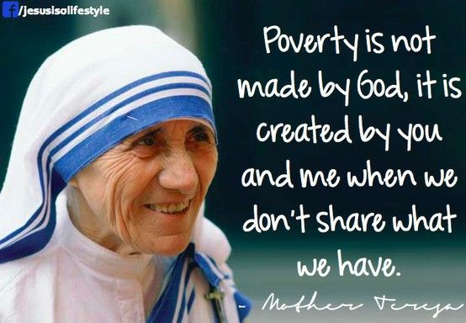
For fifteen years now the community of Hoganas from Sweden has come together to support the most vulnerable groups in Kosovo. Safety Net project has been implemented specifically at Mitrovica region as most poverty affected area. People with disabilities, Women breadwinners, Elderly and families living in deprived social situation have been selected as project target groups. During the year of 2019 alone 336 aid packages for families with 1698 members have been distributed. The sustenance contained monthly basis food and hygiene packages in addition to special care project for Merita Hasani. The community of Mitrovica is fortunate to have distance yet so close supporters to alleviate poverty rate in this region and wishes to thank so much people of Hoganas for generous donation. This is of great help for all beneficiaries.
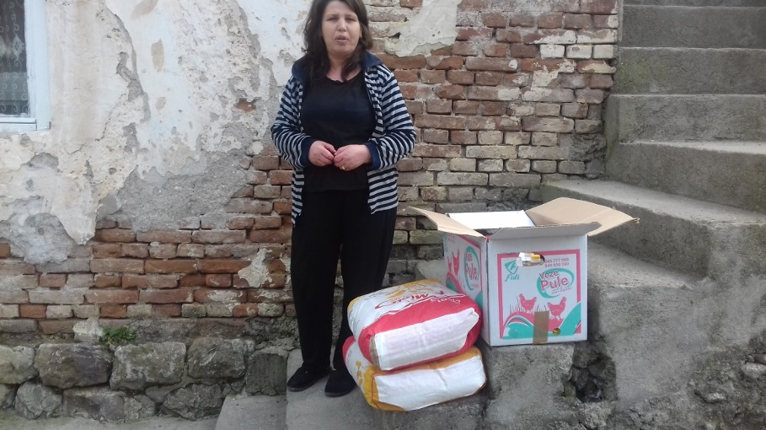
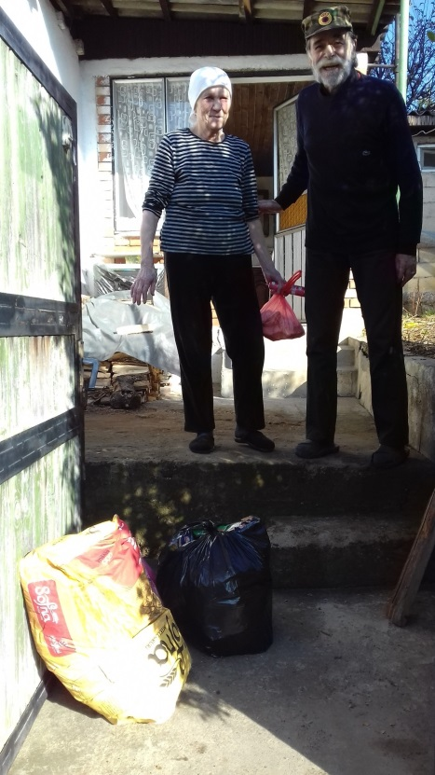

Poverty, imbalance of trade, high unemployment, and heavy reliance on remittances characterizes Kosovo. Unemployment is very high, because of the disruptions caused by the end of communist rule, conflict of 1999 and the struggle for independence thus the economy is dependent mostly on foreign aid and remittances sent from Diaspora. The unemployment rate in Kosovo was 34.8 percent in 2016, which means almost one-third of the labor force in Kosovo does not have jobs. The rate increased 0.2 percent, from 34.6 percent in 2015 to 34.8 percent in 2016. Kosovo is ranked 197th on a list of unemployment rates worldwide. Kosovo’s citizens lack affordable health services. The government’s budget for health care can only cover 60 percent of medications considered essential. Treating serious diseases like cancer is unaffordable for most families in Kosovo.

