Tittle of Action:
‘’Further development of the civil dialogue between Kosovo and Serbia".

Sub-Granting Program

Call for Proposals

NO. MTS-CFR 001-2023

Implemented by:

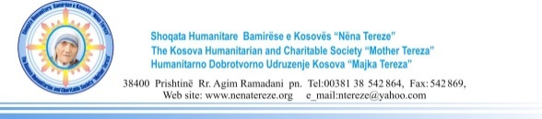
This document has been produced with the financial assistance of the European Union. The contents of this document are the sole responsibility of KHCS Mother Teresa and can under no circumstances be regarded as reflecting the position of the European Union.

The KHCS ‘’Mother Teresa’’ and ‘’Center for Regionalism’’ in the framework of the EU funded project: ‘’Further development of the civil dialogue between Kosovo and Serbia’’ are seeking proposals to support joint activities of youth CSOs from Kosovo and Serbia in the areas of employment, education, environment and culture.
Interested Civil Society Organizations (CSOs) registered in Kosovo and Serbia interested in applying for this Call for Proposals can get all the information about eligibility and criteria in the Guideline published at this link:

Application documents can be requested officially at the email mts.civic.dialogue@gmail.com

Deadline for applications: 30/09/2023 – 23:59 (CET)

